**DBMS LAB Test-2 (20-03-2025)**

**Name-** Bhavya Shrivastava **Roll No-** 23052071 **Section-** CSE-15

1. **Draw an ERD & SD of IBM DATABASE from the following description:**

**IBM has multiple departments like, coding, R&D, testing, marketing etc. Each department recruits employees. There are multiple projects handled by IBM. One project is managed by multiple departments and one department at the same time is associated with multiple projects. An employee can work on multiple projects. Each project has multiple employees and one project manager. IBM database should assign an unique department_id to every department and store information regarding department like, department name, HOD_ID, No_of_employees etc. The database should assign an unique project_no to every project and store information regarding projects like, project_manager’s_id, start_date, assigned_budget etc. IBM database should assign an unique employee_id to every employee and store information regarding employees like, name, DoB, DoJ, Phone_no etc.**

1. **Make a relational database from the above description. Create all necessary relational tables, add primary keys and foreign keys. All constraints should have appropriate names.**

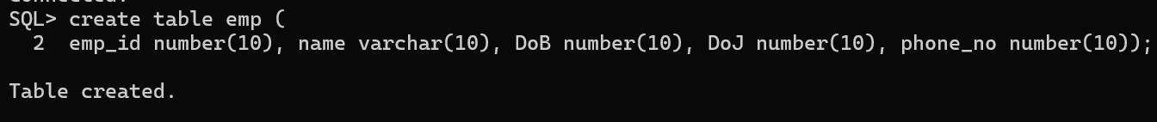

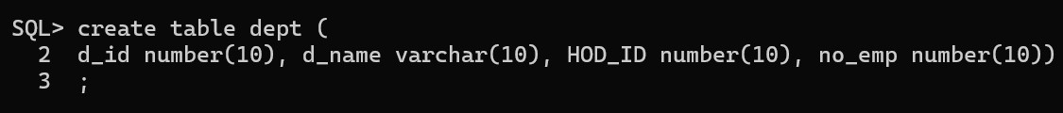

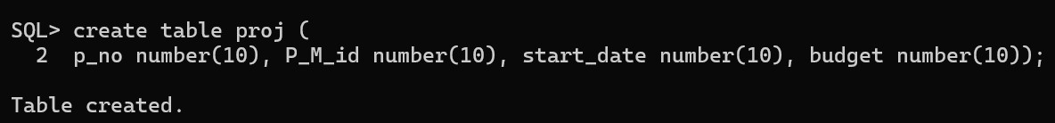

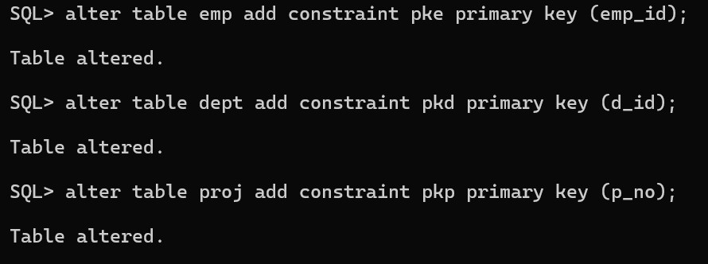

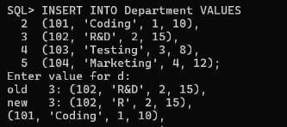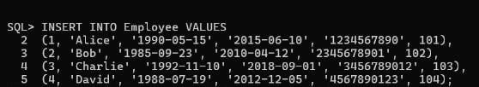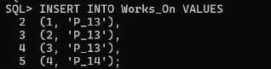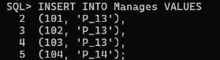

1. **Write SQL Statement for the following queries.**
2. **Find the employee’s name and his department’s name, who is the project manager of project_no = P_13.**

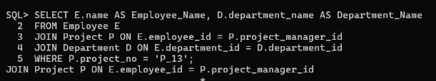

1. **Find all the employees (names, phone_no, HoD_id), who work in P_13.**

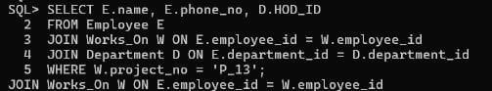

1. **Find all the employees(Names, id, DoB, DoJ), who works as either HoD of a department or manager of a project or both.**

